|  |  |  |  |
| --- | --- | --- | --- |
| **Document Revision History** | | | |
| Revision | Date | By | Remarks |
| A1 | 12/18/2019 |  | Created. |

1 High Level Business Requirement 2

2 Business Units Using the Report 2

3 Sample Layout 2

4 IFS Permissions 6

5 Fields Specification 6

6 Other Considerations/ Notes 7

# High Level Business Requirement

If a user wants to unreceive and unissued a part, from the Shop Order screen, they need to navigate two pathways. The first activity involves a RMB (“Receive->Manual Unreceive”). The second activity involves a second RMB (“Material Actions->Manual Unissue”

# Business Units Using the Functionality

Mark the plant(s) that will be using the report. Multiple can be checked.

|  |  |
| --- | --- |
| Manufacturing | X |
|  |  |
|  |  |

# Sample Layout (Existing)

The current, manual process navigates through a RMB on the Shop Order screen. Once on the Unreceive Shop Order screen, the user will enter the necessary quantities and save.

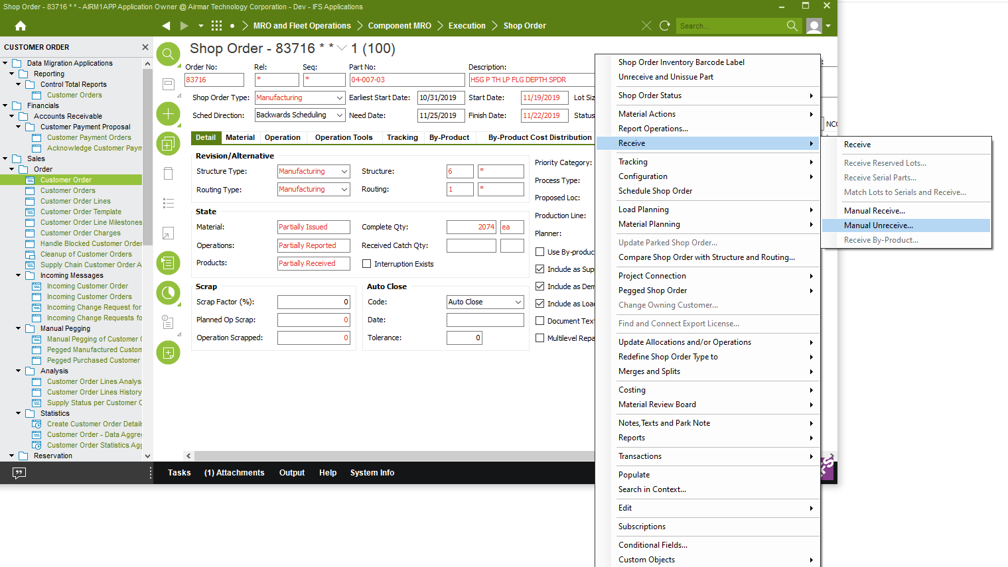

1. Shop Order screen

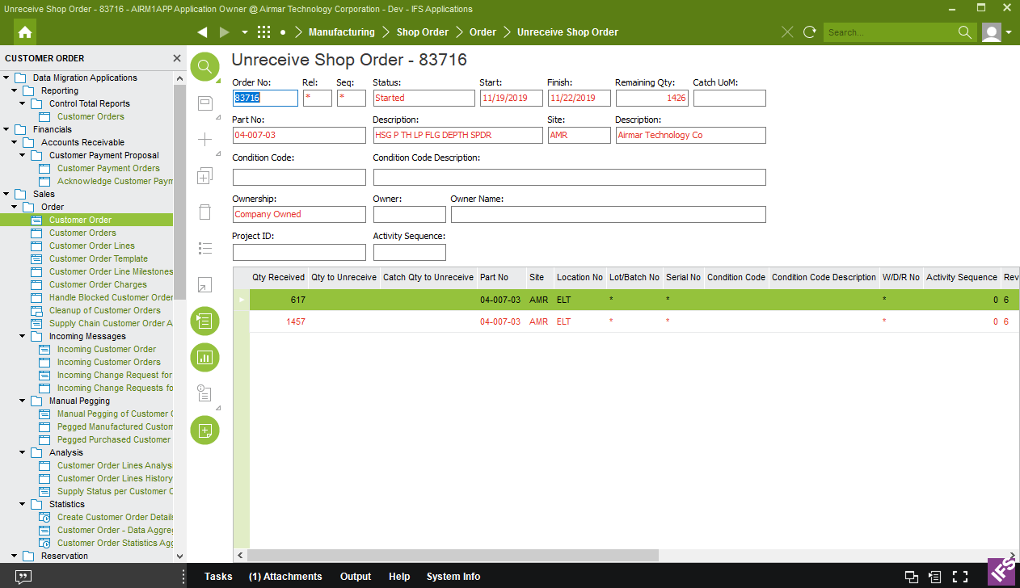

1. Unreceive Shop order screen

The Unissue process starts on the Shop Order screen, passes through the Manual Unissue Shop Order screen, and lands on the Location to Unissue screen. Once the location is chosen and the quantity entered, the processed is completed with a save.

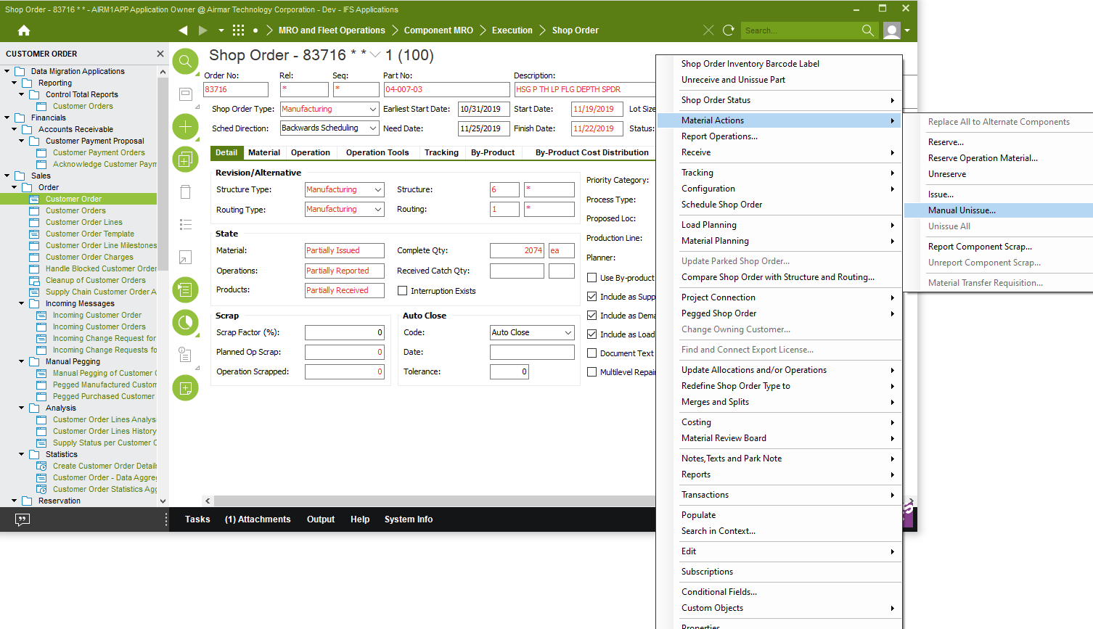

C. Shop Order screen

## Procedure

Via the ***Manual Unissue Shop Order*** window:

1. Select the material lines to un-issue. You can select one or more lines at a time.
2. Right-click anywhere in the table and then click **Location to Unissue**. The***Location to Unissue*** window appears.
3. If you selected several material lines, you can scroll among them in the **Component Part No** list.
4. Select the inventory location in which to return the material. Enter the quantity to return in the **Qty to Unissue** field. You cannot unissue more parts than you issued.
5. Save.

<https://ifstdm-apps.airmar.com:58080/ifsdoc/documentation/en/default.htm?openpage=https://ifstdm-apps.airmar.com:58080/ifsdoc/documentation/en/Shpord/frmShopOrd.htm>

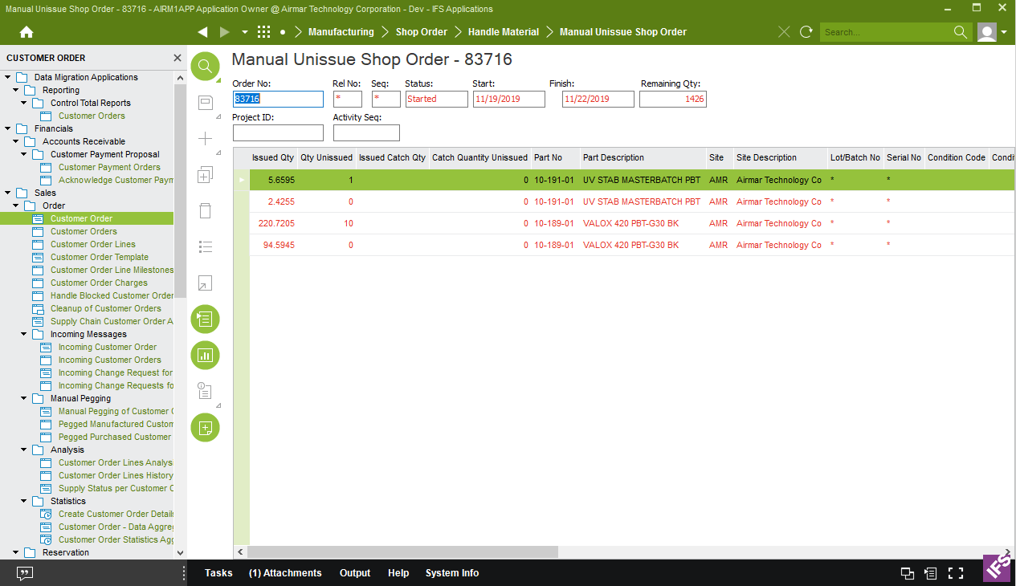

1. Manual Unissue Shop Order

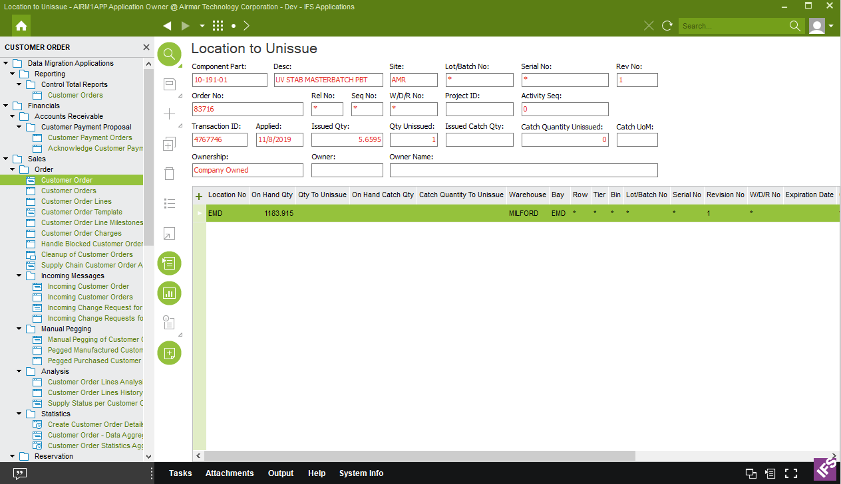

1. Location to Unissue

# IFS Permissions

Presentation Object: frmShopOrd

# Fields Specification

|  |  |  |  |  |
| --- | --- | --- | --- | --- |
| **Section** | **Name** | **Description** | **IFS Screen** | **Format** |
|  | NA |  |  |  |
|  |  |  |  |  |
|  |  |  |  |  |
|  |  |  |  |  |
|  |  |  |  |  |
|  |  |  |  |  |
|  |  |  |  |  |
|  |  |  |  |  |

# Other Considerations/ Notes

The new process combines the Unreceive and Unissue actions through a new RMB selection (Unreceive and Unissue part).

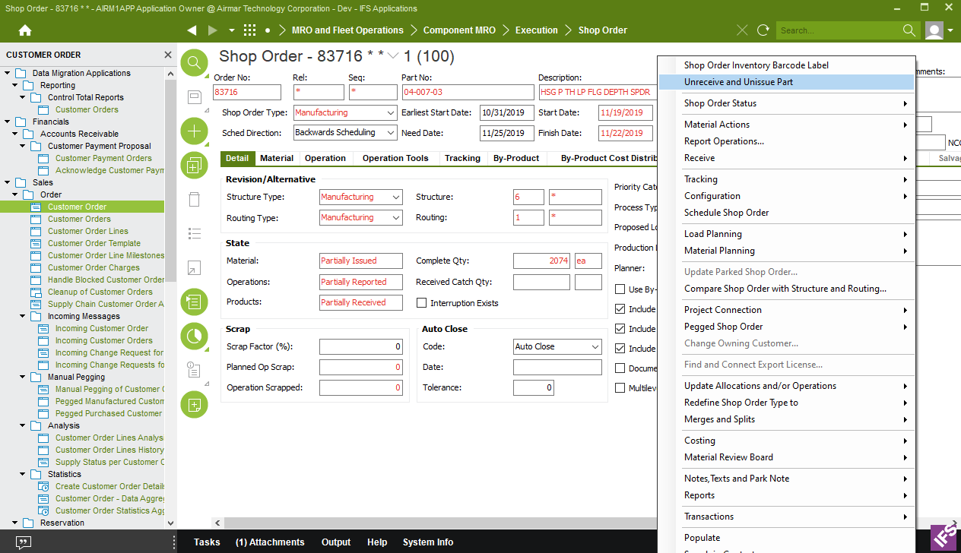

1. New RMB selection

Transaction Codes:

Unreceive part is OOREC

Unissue part is BACFLUSH

Quantities to reverse:

Unreceive part will use the full amount on all lines on the Unreceive Shop

Order Screens (Located in the details section)

Unissue part will use the full amount on all lines (minus any Qty

Unissued) on the manual Unissue Shop Order screen

DB Object: **AMR_SHOP_ORDER_API.UNRECEIVE_UNISSUE_PART**

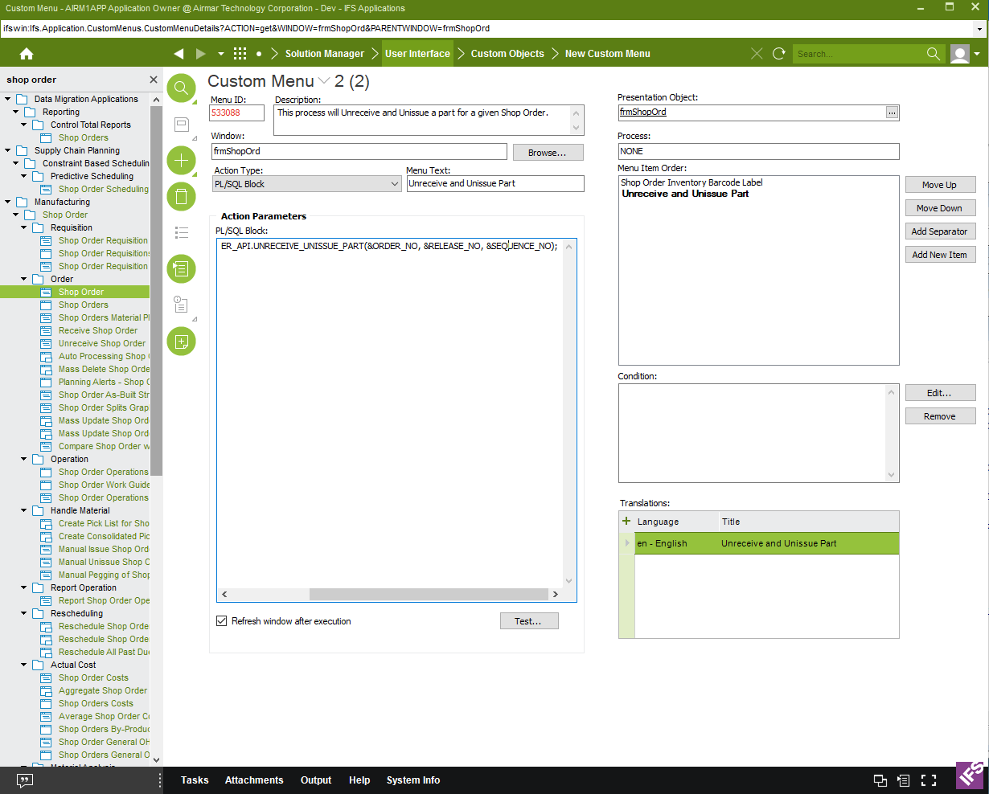

AIRM1APP.AMR_SHOP_ORDER_API.UNRECEIVE_UNISSUE_PART(&ORDER_NO, &RELEASE_NO, &SEQUENCE_NO);